CSP 554—Big Data Technologies

Assignment #1 (Modules 01a & 01b, 10 points)

Due by the start of the next class period
Assignments are to be uploaded via the Blackboard portal.
Note: There may be short quiz questions about the readings or articles and other questions available around the time of the second lecture.
- Obtain our texts
- Tom White. 2015. Hadoop: The Definitive Guide (4th ed.). O'Reilly Media, Inc (TW)
- Pramod J. Sadalage and Martin Fowler. 2012. NoSQL Distilled: A Brief Guide to the Emerging World of Polyglot Persistence. Addison-Wesley.(PS)

- Read from (TW)
- Chapter 1 (note this chapter is also on Blackboard “Free Books and Chapters” so you don’t need to wait for the book to arrive)
- Chapter 3

- Read an article on “Blackboard” in the “Articles” section
- The Parable of Google Flu (just 3 pages!)

- (5 points) Answer each of the following questions about the article in just one to three sentences each:
  - What was the problem with the Google flu detection algorithm?
  - What is big data hubris?
  - What approach could have been used to improve the Google flu detection algorithm?
  - What is “algorithm dynamics?”
  - What aspect of algorithm dynamics impacted the Google flu detection algorithm?

- (3 points) Set up an Amazon Web Services (AWS) cloud account, if you don’t already have one (see below for details). Since we will do most of our assignments using AWS, this will get you started.

- We will be using AWS services that are not supported by AWS educational accounts. So, if you do not have access to a regular personal (or business) AWS account you will need to create one (we will point you to step by step instructions describing how to do this). And to establish a regular account you will need a valid credit card. Assignments in this course are carefully structured so your cloud costs should be minimal (no more than $5-$7 per month, and usually much less). But you must follow assignment directions and remember to release cloud resources when instructed, otherwise your costs may be (much) higher.

- To sign up for an AWS account, you just need to follow the first two modules of the “Setting Up Your AWS Environment” tutorial located at the link below (but be sure to read the notes below before you start):
https://aws.amazon.com/getting-started/guides/setup-environment/?pg=gs&sec=gtkaws
The two modules you need to complete are: “Create your AWS account” and “Configure users”.

Note 1: The email that AWS sends to verify your email address often appears in your spam folder, especially if you use Gmail. So, wait a few minutes and then look in all your email folders.

Note 2: When asked to choose a support plan, just accept the default: “Basic support – Free.” There is no need whatsoever to have a support plan for which you have to pay.

Note 3: If you can just make it all the way through the module “Create your AWS account” then you can perform all course exercises. Successfully completing the module “Configure users” is important, if you can do it, as it will ensure your AWS account is more secure from malicious access. Next best, is completing the module “Configure users” at least to the point where you have set up multi-factor authentication (MFA) on your root account.

Note 4: At some point when following the “Configure users” module you will need to choose and authenticator app for your mobile phone. Microsoft Authenticator is a good free choice. If you install this app, when the time comes scan for a QR code if you are using an iPhone (a) press “+” in the top right corner of the app, and (b) select “Other (Google, Facebook etc.)”, then scan for the QR code. It should be similar for an Android phone. But if you prefer Google Authenticator, or some other app, that is fine too.

- To get credit for this part of the assignment, provide a screen shot of the main page of the AWS management console page including your account name (see arrow)similar to the example below:
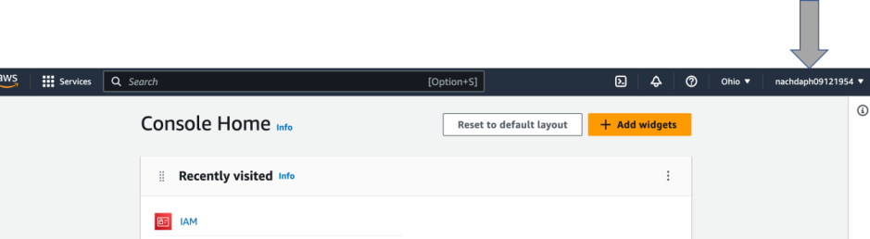

- (2 points) Now follow the below steps about how to work with an AWS object storage service called S3 (Simple Storage Service). In a while we will come to understand S3 as one critical element of a big data processing architecture known as the “data lake.

- Amazon Simple Storage Service (Amazon S3) is storage for the internet. You can use Amazon S3 to store and retrieve any amount of data at any time, from anywhere on the web. Amazon S3 stores data as objects within buckets. An object is a file and any optional metadata that describes the file. To store a file in Amazon S3, you upload it to a bucket. When you upload a file as an object, you can set permissions on the object and any metadata. Buckets are containers for objects. You can have one or more buckets. You can control access for each bucket, deciding who can create, delete, and list objects in it. You can also choose the geographical Region where Amazon S3 will store the bucket and its contents and view access logs for the bucket and its objects.
- If you want more details about AWS S3 object storage refer to the section “Overview of Amazon S3” at the end of this document.
- Creating a bucket
Now that you've signed up for AWS, you're ready to create a bucket using the AWS Management Console. Every object in Amazon S3 is stored in a bucket. Before you can store data in Amazon S3, you must create a bucket.
Note: You are not charged for creating a bucket. You are charged only for storing objects in the bucket and for transferring objects in and out of the bucket.
To create a bucket:
  - Sign in to your AWS account. Type “s3” into the services search box and then press the “Enter” key:
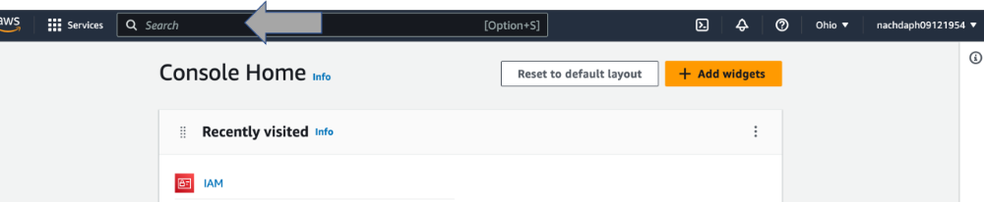
  - Notice the menu on the left side of the page. Each entry, such as “Buckets” results in the display of a different screen, which allows you to perform specific functions. Sometimes the menu collapses to save space. It is then replaced by three stacked horizontal bars in the top right corner of the screen. Click on that symbol to reveal the full menu.
  - Choose the “Create bucket” button towards the top right of your screen and then the Create bucket page opens.
  - In Bucket name, enter a DNS-compliant name for your bucket. The bucket name must: (a) Be unique across all of Amazon S3 bucket names in the world; (b) Be between 3 and 63 characters long; (c) Not contain uppercase characters; (d) Start with a lowercase letter or number After you create the bucket, you can't change its name. As one possibility, the bucket should be named something like “YourIITId-CSP554”, for example: “A1234567_CSP554”
  - In Region, choose the AWS Region where you want the bucket to reside. Choose a Region close to you to minimize latency and costs and address regulatory requirements. Objects stored in a Region never leave that Region unless you explicitly transfer them to another Region.
  - Scroll down to see more of the screen.
  - In Bucket settings for Block Public Access, keep the values set to the defaults. By default, Amazon S3 blocks all public access to your buckets. We recommend that you leave all Block Public Access settings enabled.
  - Keep scrolling down until you see the “Create bucket” button. Choose Create bucket. Now you've created a bucket in Amazon S3.
- Now that you've created a bucket, you're ready to upload an object to it from your PC or Mac (or any other computer). An object can be any kind of file: a text file, a photo, a video, and so on.
To upload an object to a bucket
  - In the Buckets list, choose the name of the bucket that you want to upload your object to. To do so, just click on the name of your bucket, and then the Objects screen should appear.
  - On the Objects screen for your bucket, choose Upload.
  - Under Files and folders, choose Add files.
  - Choose a file to upload, and then choose Open. When asked to upload a file to the S3 bucket you have created, just use any text file you have handy (even this one).
  - Choose Upload (this is a button towards the bottom of the page). You've successfully uploaded an object to your bucket.

To receive credit for this question, provide a screen shot showing some named object is in the bucket. Note, this is the screen that appears after you choose the Upload button.

- If you completed this assignment and do not plan to use your bucket or objects, we strongly recommend that you delete your bucket so that charges no longer accrue. Before you delete your bucket, you must empty the bucket or delete the objects in the bucket. After you delete your objects and bucket, they are no longer available.

To empty a bucket
  - In the Buckets list, select the bucket that you want to empty (by clicking on the little circle to the left of the bucket name), and then choose Empty.
  - To confirm that you want to empty the bucket and delete all the objects in it, in Empty bucket, enter the words “permanently delete.”
  - Important, emptying the bucket cannot be undone. Objects added to the bucket while the empty bucket action is in progress will be deleted.

Important: Deleting a bucket cannot be undone. Bucket names are unique. If you delete your bucket, another AWS user can use the name. If you want to continue to use the same bucket name, don't delete your bucket. Instead, empty and keep the bucket.
Deleting your bucket
  - From the left hand side menu select “Buckets” and the list of buckets should appear
  - To delete a bucket, in the Buckets list, select the bucket (by clicking on the little circle to the left of the bucket name).
  - Choose Delete.
  - To confirm deletion, in Delete bucket, enter the name of the bucket.
  - Now select the “Delete bucket” button
You are now done with this assignment!

Overview of Amazon S3
Amazon S3 a simple web services that you can use to store and retrieve any amount of data. It is used as part of a big data architecture called a “data lake” that we will discuss later.

Advantages to Amazon S3
Amazon S3 is intentionally built with a minimal feature set that focuses on simplicity and robustness. Following are some of advantages of the Amazon S3 service:
- Create Buckets – Create and name a bucket that stores data. Buckets are the fundamental container in Amazon S3 for data storage.
- Store data in Buckets – Store an infinite amount of data in a bucket. Upload as many objects as you like into an Amazon S3 bucket. Each object can contain up to 5 TB of data. Each object is stored and retrieved using a unique developer-assigned key. Data stored in S3 is “write once, read many.” This means that once written, data can’t be appended to or updated.
- Download data – Download your data or enable others to do so. Download your data any time you like or allow others to do the same.
- Permissions – Grant or deny access to others who want to upload or download data into your Amazon S3 bucket. Grant upload and download permissions to three types of users. Authentication mechanisms can help keep data secure from unauthorized access.
- Standard interfaces – Use standards-based REST interface designed to work with any Internet-development toolkit.

Amazon S3 Concepts
This section describes key concepts and terminology you need to understand to use Amazon S3 effectively. They are presented in the order you will most likely encounter them.

Buckets
A bucket is a container for objects stored in Amazon S3. Every object is contained in a bucket. For example, if the object named photos/puppy.jpg is stored in the johnsmith bucket, then it is addressable using the URL http://johnsmith.s3.amazonaws.com/photos/puppy.jpg
Buckets serve several purposes: they organize the Amazon S3 namespace at the highest level, they identify the account responsible for storage and data transfer charges, they play a role in access control, and they serve as the unit of aggregation for usage reporting.
You can configure buckets so that they are created in a specific region. For more information, see Buckets and Regions. You can also configure a bucket so that every time an object is added to it, Amazon S3 generates a unique version ID and assigns it to the object. For more information, see Versioning.

Objects
Objects are the fundamental entities stored in Amazon S3. Objects consist of object data and metadata. The data portion is opaque to Amazon S3. The metadata is a set of name-value pairs that describe the object. These include some default metadata, such as the date last modified, and standard HTTP metadata, such as Content-Type. You can also specify custom metadata at the time the object is stored.
An object is uniquely identified within a bucket by a key (name) and a version ID. For more information, see Keys and Versioning.

Keys
A key is the unique identifier for an object within a bucket. Every object in a bucket has exactly one key. Because the combination of a bucket, key, and version ID uniquely identify each object, Amazon S3 can be thought of as a basic data map between "bucket + key + version" and the object itself. Every object in Amazon S3 can be uniquely addressed through the combination of the web service endpoint, bucket name, key, and optionally, a version. For example, in the URL http://doc.s3.amazonaws.com/2006-03-01/AmazonS3.wsdl, "doc" is the name of the bucket and "2006-03-01/AmazonS3.wsdl" is the key.

